**Hikmatullah Nasiri 11816103 Programming in R CA 3**

**Q1.** Using ‘WHO’ dataset, derive a new column ‘Over60Population’ that contains number of persons that are above 60 years of age for each country.

**Answer1.**

library(tidyr)  
library(dplyr)  
WHO <- read.csv("D:/LPU/6th Semester/Practice/Programming in R/# 5 lec Data files/WHO.csv")  
str(WHO)  
names(WHO)  
Over60Population<-select(WHO,starts_with("Over"))  
str(Over60Population)  
Over60Population[1:10,]

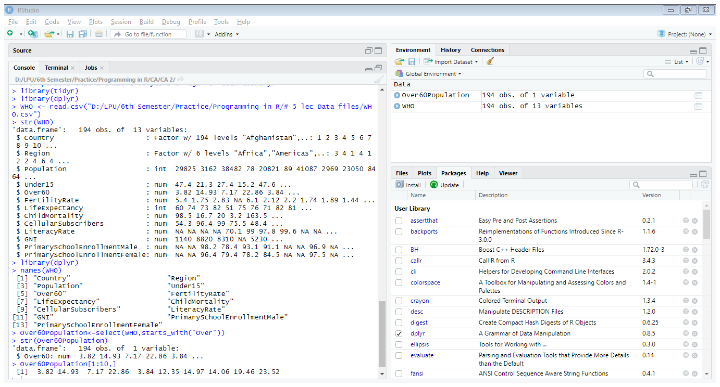

**Q2**. Using ‘WHO’ dataset, derive a new dataset who2, where ‘PrimarySchoolEnrollmentMale’ and ‘PrimarySchoolEnrollmentFemale’ are united to give a new column ‘PrimarySchool’ with comma as a separator.

**Answer2.**

library(tidyr)

who2<-unite(WHO,"PrimarySchool", PrimarySchoolEnrollmentMale,   
 PrimarySchoolEnrollmentFemale,sep=",")

str(who2)

View(who2)

**Output:**

'data.frame': 194 obs. of 12 variables:

$ Country : Factor w/ 194 levels "Afghanistan",..: 1 2 3 4 5 6 7 8 9 10 ...

$ Region : Factor w/ 6 levels "Africa","Americas",..: 3 4 1 4 1 2 2 4 6 4 ...

$ Population : int 29825 3162 38482 78 20821 89 41087 2969 23050 8464 ...

$ Under15 : num 47.4 21.3 27.4 15.2 47.6 ...

$ Over60 : num 3.82 14.93 7.17 22.86 3.84 ...

$ FertilityRate : num 5.4 1.75 2.83 NA 6.1 2.12 2.2 1.74 1.89 1.44 ...

$ LifeExpectancy : int 60 74 73 82 51 75 76 71 82 81 ...

$ ChildMortality : num 98.5 16.7 20 3.2 163.5 ...

$ CellularSubscribers: num 54.3 96.4 99 75.5 48.4 ...

$ LiteracyRate : num NA NA NA NA 70.1 99 97.8 99.6 NA NA ...

$ GNI : num 1140 8820 8310 NA 5230 ...

$ PrimarySchool : chr "NA,NA" "NA,NA" "98.2,96.4" "78.4,79.4" ...

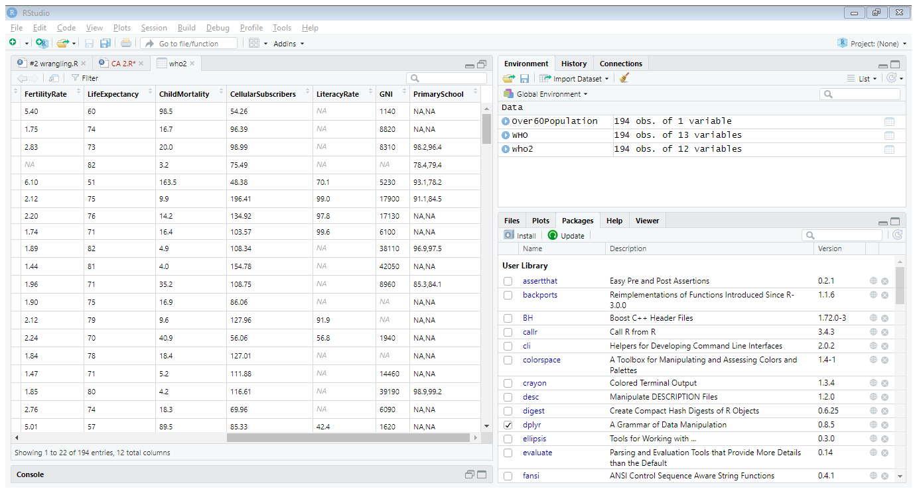

**Q3.** Using ‘WHO’ dataset, filter a subset ‘who_SEA’ that contains countries from ‘South-East Asia’ region only.

**Answer3.**

who_SEA<-filter(WHO,Region=="South-East Asia" )

View(who_SEA)

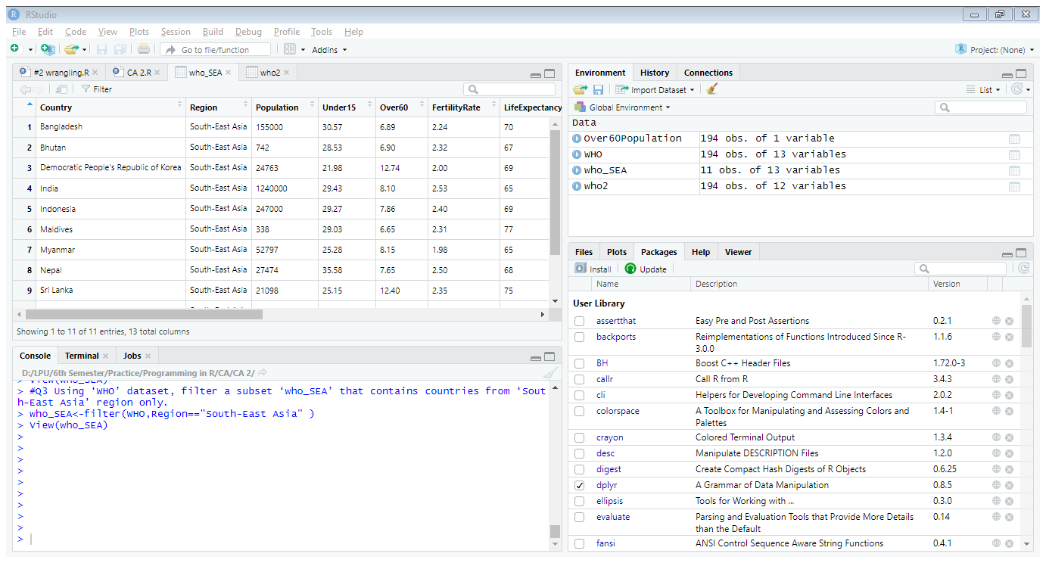

**Q4.** Using ‘mtcars’ datset, where ‘cyl’ and ‘gear’ are united to give a new column named as ‘cyl and gear’ with comma as a separator between two values.

**Answer4.**

who_SEA<-filter(WHO,Region=="South-East Asia" )

library(tidyr)

str(mtcars)

mtcars2<-unite(mtcars,"cyl and gear",cyl,gear,sep=",")

View(mtcars2)

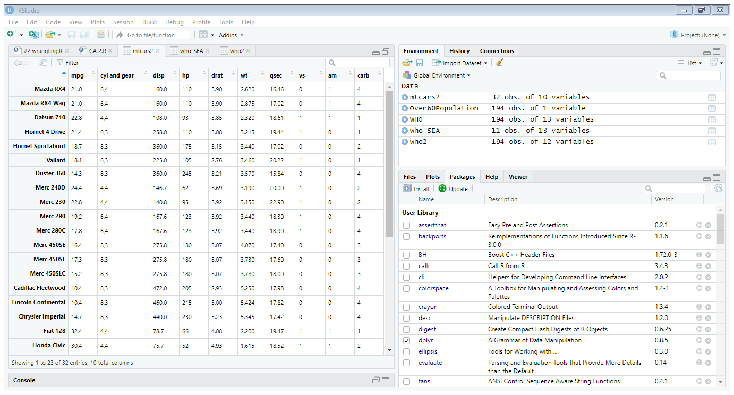

**Q5.** Using ‘mtcars’ dataset, draw a scatterplot showing ‘mpg’ Vs ‘wt’. Write your interpretation about the graph.

**Answer5.**

library(ggplot2)

str(mtcars)

mtcars$mpg

plot(mtcars$mpg,mtcars$wt,main = "Weight with respect to Average",xlab="Mileage",ylab ="Weight")

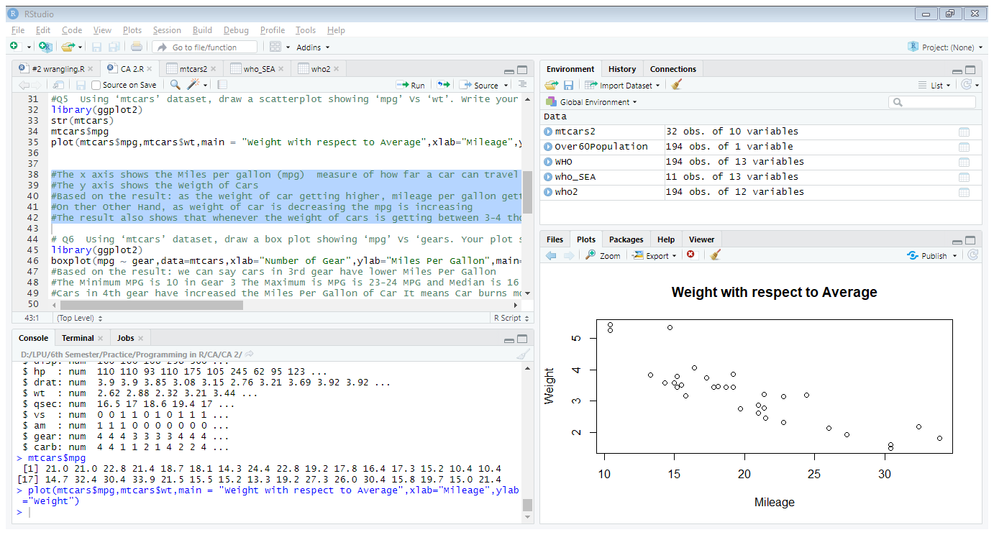

* The x axis shows the Miles per gallon (mpg) measure of how far a car can travel if you put just one gallon of petrol or diesel in its tank.
* The y axis shows the Weight of Cars
* Based on the result: as the weight of car getting higher, mileage per gallon getting lower
* On the Other Hand, as weight of car is decreasing the mpg is increasing
* The result also shows that whenever the weight of cars is getting between 3-4 thousand lbs. the MPG increases

**Q6.** Using ‘mtcars’ dataset, draw a box plot showing ‘mpg’ Vs ‘gears. Your plot should have three box-plots separate for cars with 3, 4 & 5 gears. Write your interpretation of the plot.

**Answer6.**

library(ggplot2)

str(mtcars)

boxplot(mpg ~ gear, data=mtcars, xlab="Number of Gear", ylab="Miles Per Gallon", main="Milege Data With Respect To Car Gears", col = c("green","red","orange"))

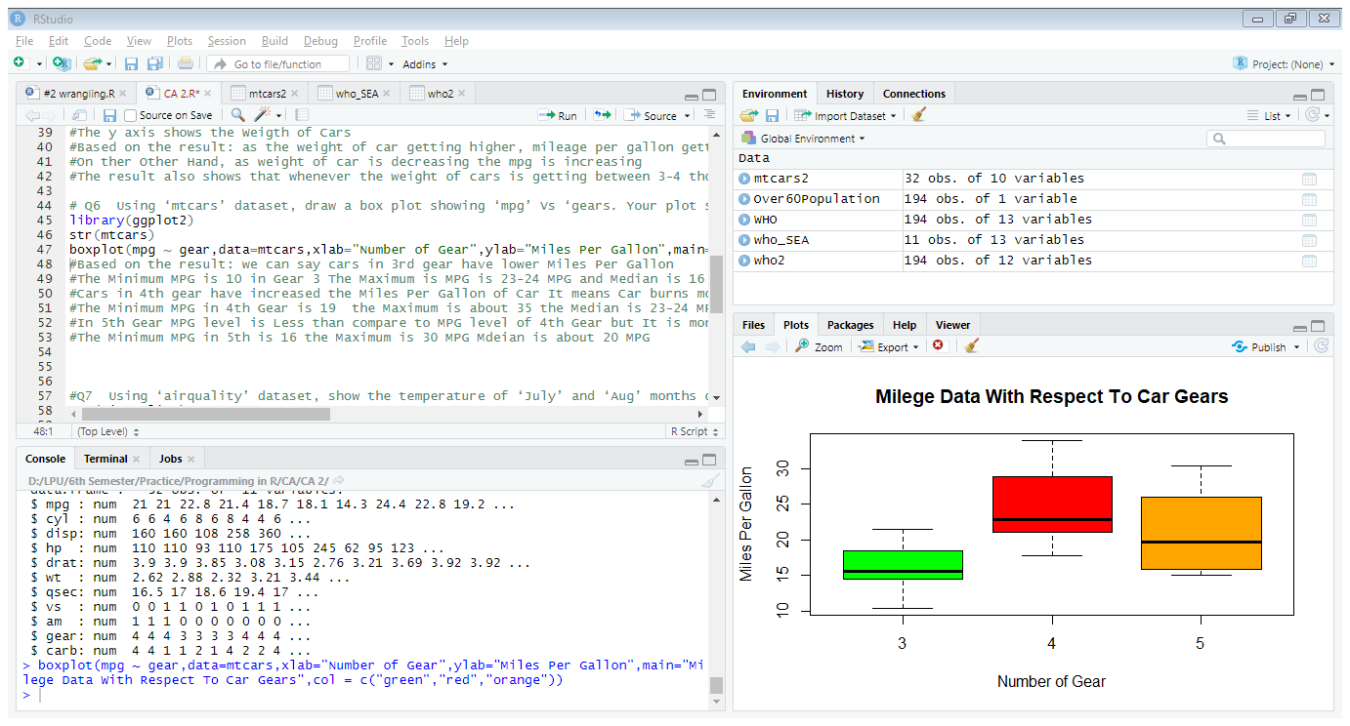

* Based on the result: we can say cars in 3rd gear have lower Miles Per Gallon
* The Minimum MPG is 10 in Gear 3 The Maximum is MPG is 23-24 MPG and Median is 16 MPG in 3rd Gear
* Cars in 4th gear have increased the Miles Per Gallon of Car It means Car burns more fuel in 4th Gear
* The Minimum MPG in 4th Gear is 19 the Maximum is about 35 the Median is 23-24 MPG in 4th Gear
* In 5th Gear MPG level is Less than compare to MPG level of 4th Gear but It is more than 3th Gear
* The Minimum MPG in 5th is 16 the Maximum is 30 MPG Median is about 20 MPG

**Q7.** Using ‘airquality’ dataset, show the temperature of ‘July’ and ‘Aug’ months on the same line graph. Use separate color for both the lines. Write your interpretation about the plot.

**Answer7.**

str(airquality)  
airquality$Month  
airqJul<-filter(airquality,Month==6)  
airqAug<-filter(airquality,Month==7)  
airqJul$Month  
airqAug$Month  
plot(airqJul$Temp,type="o", col="red", xlab="Days", ylab=" Temperature ",   
main=" Temperature in July and August")  
lines(airqAug$Temp,type="o",col="blue")

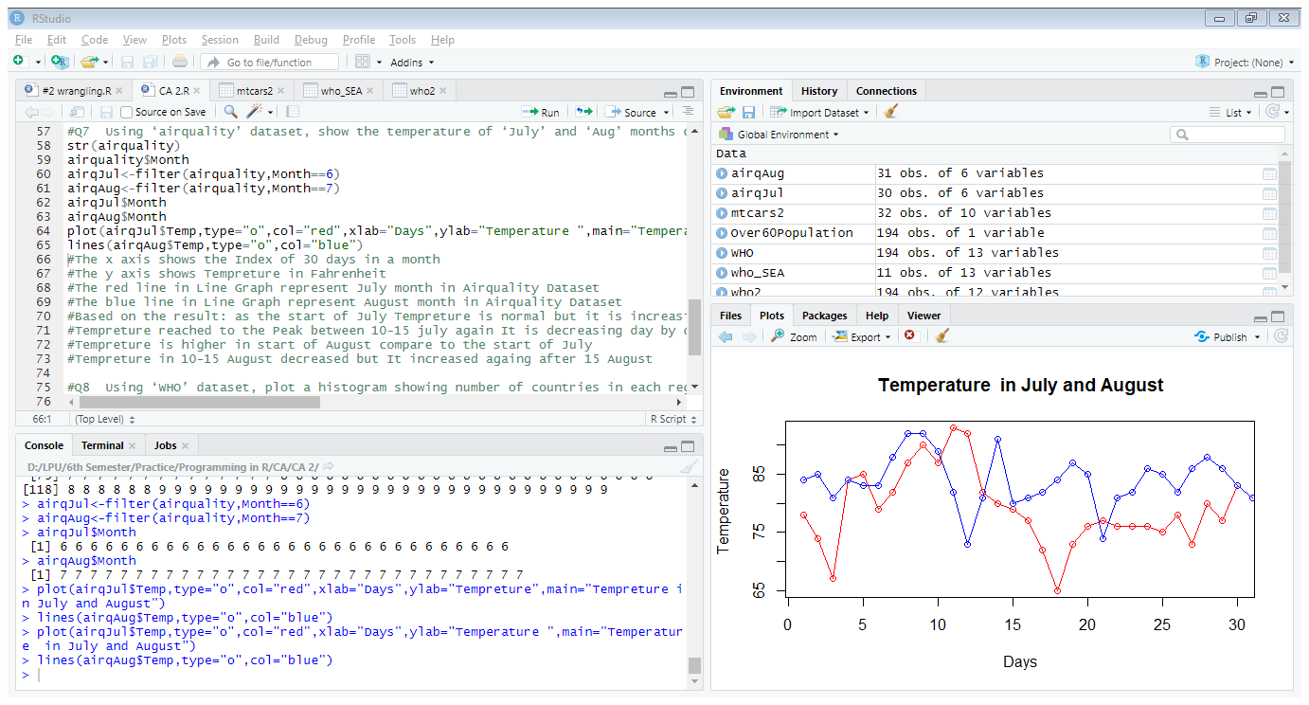

* The x axis shows the Index of 30 days in a month
* The y axis shows Temperature in Fahrenheit
* The red line in Line Graph represent July month in Airquality Dataset
* The blue line in Line Graph represent August month in Airquality Dataset
* Based on the result: as the start of July Temperature is normal but it is increasing day by day
* Temperature reached to the Peak between 10-15 July again It is decreasing day by day
* Temperature is higher in start of August compare to the start of July
* Temperature in 10-15 August decreased but It increased again after 15 August

**Q8.** Using ‘WHO’ dataset, plot a histogram showing number of countries in each region. **Answer8.**

library(ggplot2)

WHO <- read.csv("D:/LPU/6th Semester/Practice/Programming in R/# 5 lec Data files/WHO.csv")

Regions<-as.numeric(factor(WHO$Region))

hist(Regions,main=" Histogram of Countries in Each Region", xlab="Regions",ylab="Frequency",col=rainbow(6),border="blue")

legend("topright",c("Africa","Americas","Eastern Mediterranean","Europe","South-East Asia","Western Pacific"),cex =0.65,fill=rainbow(6))

